Exp no 11

IOT BASED SMART

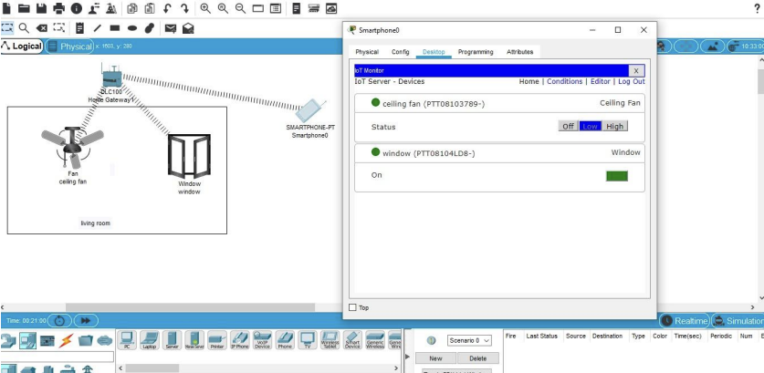

EXP NO 12

SMART GARDEN

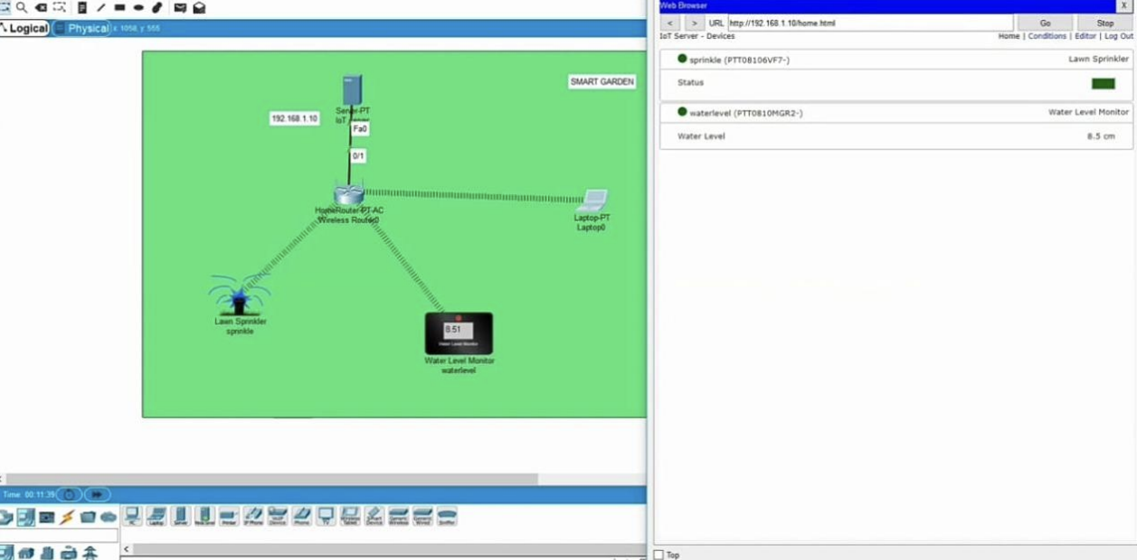

EXP NO 13:

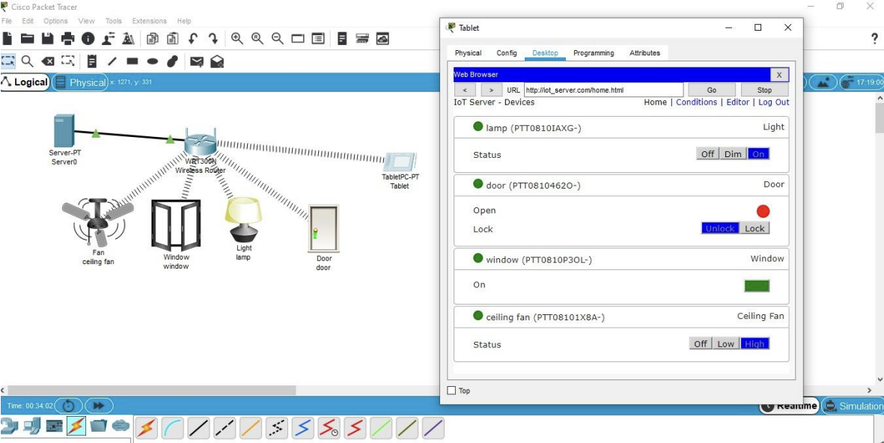

EXP NO :14

X,Y,Z COMPANY DESIGN

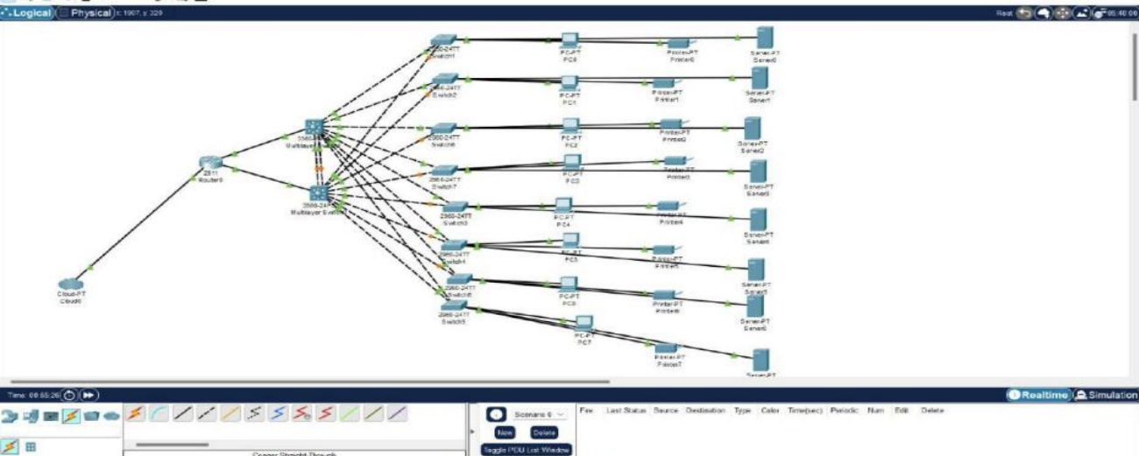

EXP NO :15

COMPUTER LAB

